|  |
| --- |
| Singleton  An Antipattern |

Abstract

The application discussed in this document examines the characteristics of the antipattern: Singleton.

As part of the empirical testing of the Singleton instance, an instance of the (canonical) class java.util.concurrent.CyclicBarrier is leveraged to assail the state and the thread-safety of the Singleton.

Also as part of the empirical testing of the Singleton, an instance of the (canonical) Java 8 class Executors.newWorkStealingPool is leveraged to supply the Threads to the CyclicBarrier which assail the state and the thread-safety of the Singleton.

Additionally, there are a few tactical measures to take to create a truly impenetrable Singleton.

All of the above are discussed in sections of this document.

This document is divided into 3 parts:

Part One Covers Singleton topics (page 3).

Part Two Covers Singleton -testing topics/classes (page QQQ ).

Part Three Discusses tactics used to thwart obscure security/integrity

exploits against a Singleton (page QQQ).

I could have used JMeter, but this approach is more fun, more flexible.



Considerations, security and integrity

A good Singleton protects against backdoor exploits that can compromise its state. Ideally it is *stateless*, or its state is immutable.

That is a naïve approach to crafting a solid Singleton. A good Singleton protects against backdoor exploits that can compromise its behavior.



Organization

**Part One** begins on page 3 and covers Singleton topics.

**Part Two** begins on page QQQ and covers Singleton-testing topics/classes.

**Part Three** begins on page AFTER 15 and tactics to thwart obscure exploits.

These more obscure exploits occur via:

Serialization mechanisms – readObject(), writeObject()

Reflection mechanisms

Bytecode Instrumentation/Proxy as fundamental risk.



Part One

Singleton Creation

In Java, a Singleton can be created in three ways.

The first way listed below is built into Java.

The other two ways are Templates, examples of which can be found on Wikipedia.

java.lang.Enum (3 lines of code, w/ braces)

Double-checked locking (13 lines of code, w/ braces)

Initialization-on-demand holder idiom (9 lines of code, w/braces)

The demo app covered in this document uses a variant of the *Initialization-on-demand holder idiom.* My treatment omits the nested (inner) “holder” class, which is unnecessary.

For the *Initialization-on-demand holder idiom*, there is an iron-clad guarantee of thread-safe construction, afforded by the JLS and enforced by the JVM.

See next page for the Singleton class and an in-depth discussion of its features.

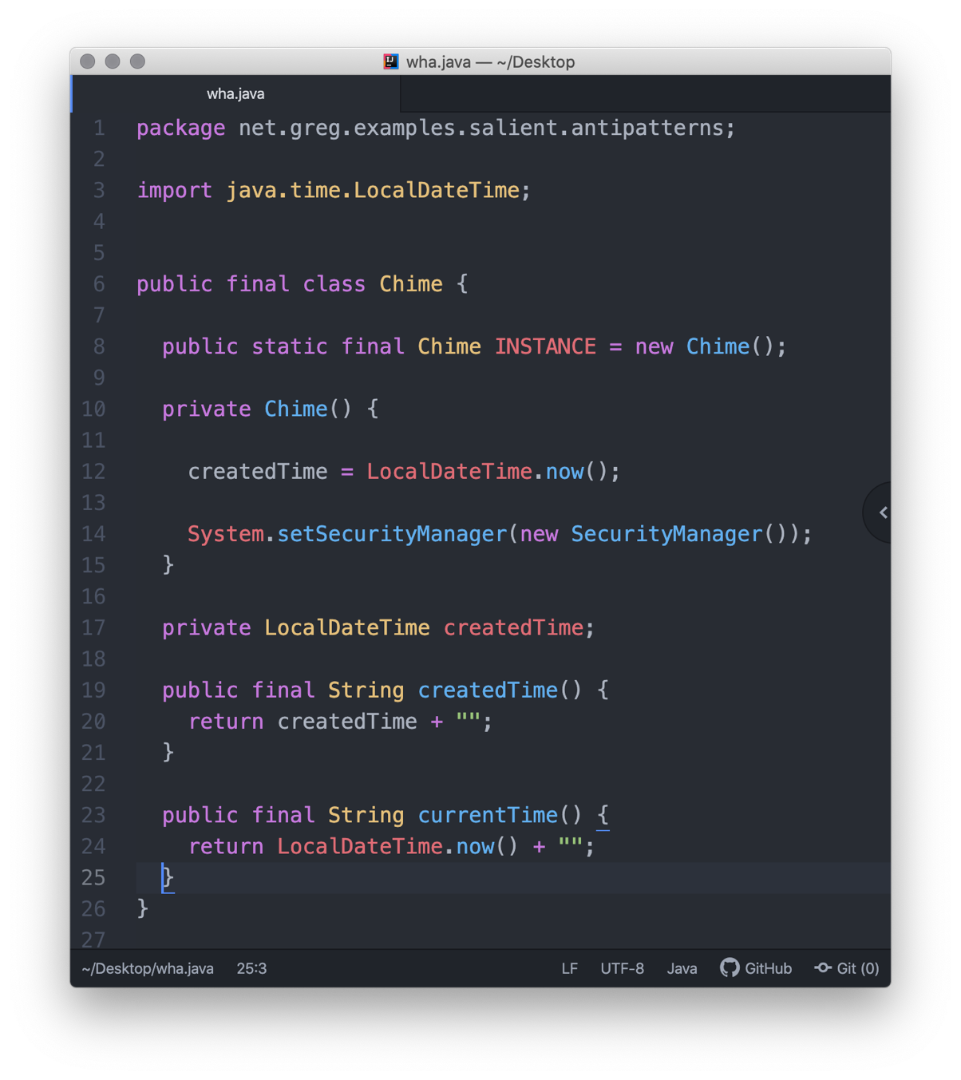

Line 8 (*safe publication*)

The static keyword means that the INSTANCE attribute’s initialization happens-before

that of all/any instance-level attributes.

The final keyword means that the INSTANCE attribute must be reified (assigned a value)

before the constructor (which has private accessibility) can publish a usage instance.

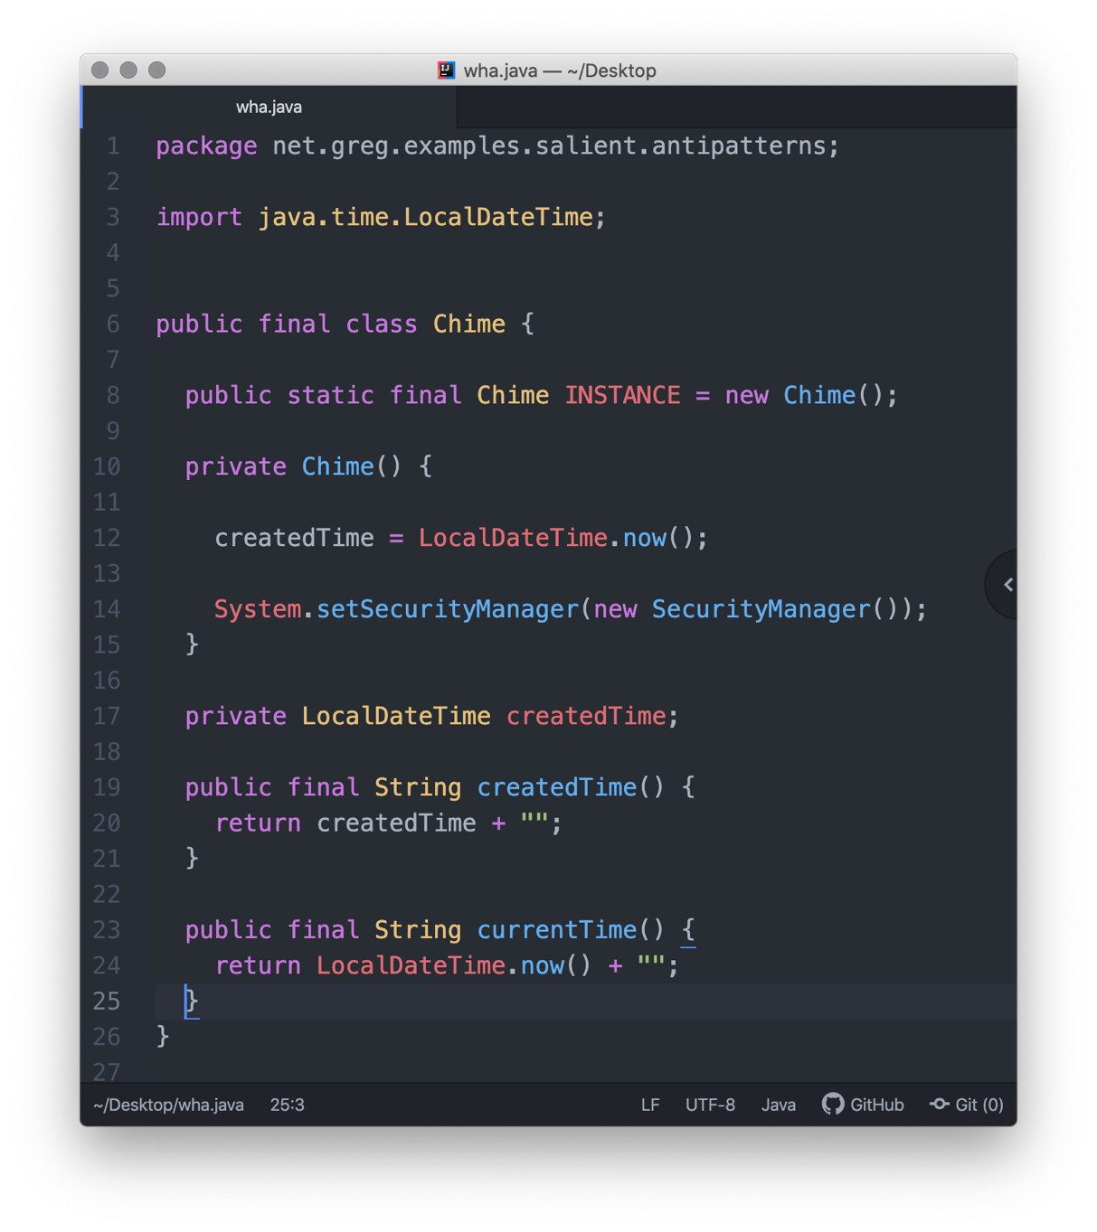

Lines 10-14 (the createdTime *instance-level* attribute)

The constructor‘s private keyword means that accessibility is denied to any class, except this class.

The createdTime attribute is declared elsewhere but is defined here.

The createdTime attribute is *effectively-final*, because this class’ constructor is called *exactly-once*.

The constructor is called *exactly-once* because it is R-value that is assigned to *the final keyword on line 8*.

The constructor has a routine that disables the Security Manager, with the intent of preventing the

(default) ability to use Reflection.

The side effect of doing this is that key capabilities, such as Modify Thread state, Shutdown Hook operation, are also disabled. Runtime attempts to use them result in a java.security.AccessControlException (see next two screen shots).

One remedy to reinstate these capabilities involves adding grant {} statements to Java’s canonical security file $HOME/.java.policy (which is hidden-by-a-leading-period).

For details, refer to the Exploits Section at the end of this document.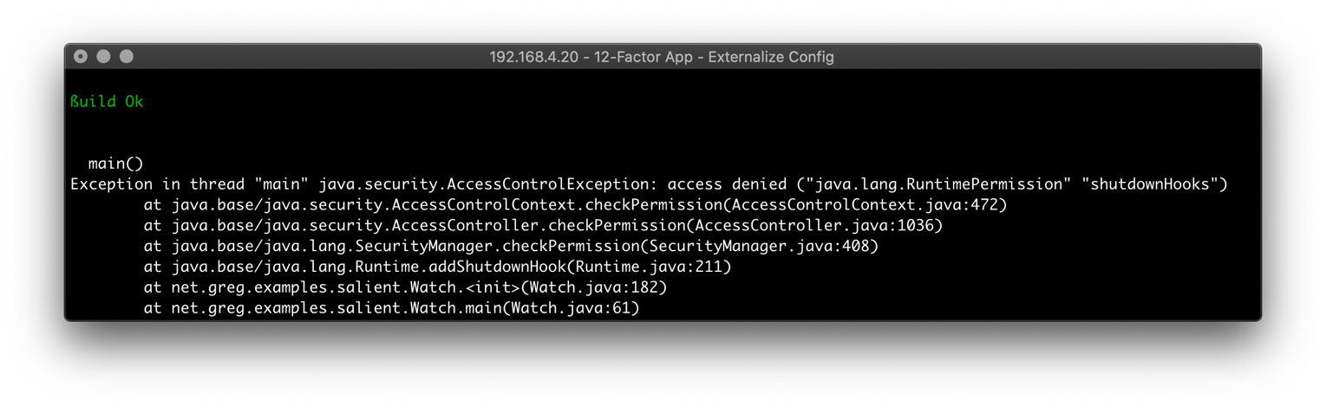

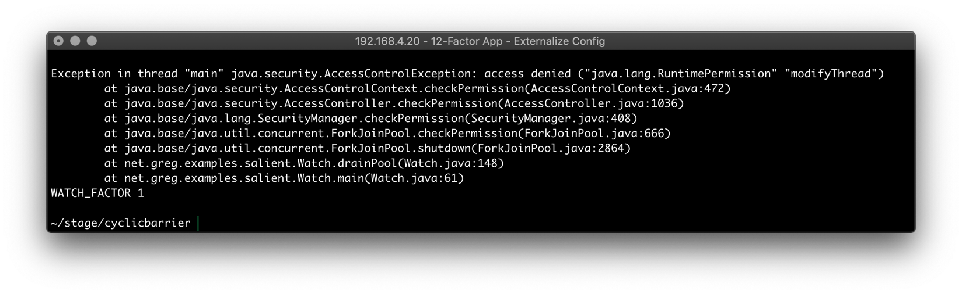

Singleton assessment

continues

**

Line 17 (the createdTime *instance-level* *attribute*)

The private keyword means that accessibility is granted via a convenience method (if at all).

This createdTime attribute is declared, but its initialization is deferred to the constructor.

Lines 19-20 (the createdTime *instance-level* *method* for publication)

The private createdTime attribute’s state is exposed (as a metrics insight) by the eponymously-named createdTime() convenience method.

Lines 23-24 (the currentTime *instance-level method*)

The public instance-level method exposes the current time as the key functionality of this Singleton class.

The current time value is ephemeral/transient – that is, it is not stored.

Singleton’s Innate Flaws

In its construction, the Singleton is well thought out.

But in its application – unless it’s stateless/immutable – a Singleton’s role is constrained and it fails in important ways.

For instance, if there it has no logic/behavior, and also no mutable state, a Singleton is reduced to either playing the of a ValueObject, or to acting as an intercessor for access to third-party externalities.

Should those externalities not prove to be thread-safe, you introduce into the codebase, thread-safety issues.

NB Spring has a default bean lifecycle scope of Singleton.

It would make more sense to default the bean lifecycle scope that of Prototype.

This optimization favors correctness over speed (still, Spring is notoriously slow).



I. State

A Singleton claims to be a singular, unique instance of a class. Within a given address-space (JVM) this claim is true. But, a Singleton instance – in any distributed architecture (like “the cloud”) – crosses address-spaces (JVMs).

When a Singleton crosses address-spaces/JVMs in a replicated set of nodes (Pods, Docker Swarm), suddenly there are two “unique” instances, with possibly different internal state.

Holding state is incorrect in itself because a good Singleton is *stateless*.

A more subtle problem arises when a Singleton – having been serialized sent across the wire and deserialized into another address space – is referenced.

In a replicated environment, which “Singleton” is *the one*?

NB A java.lang.Enum is the only built-in way to create a Singleton.

It is immutable, has no constructor, and it *cannot* be serialized.

An Enum is *close* to being the ideal Singleton; however, its

behavior can vary depending upon differences in the address

space in which it executes.



II. Memory Leakage

A Singleton lays claim to any object graph to which it holds a reference (which is incorrect in itself, because a good Singleton is *stateless*).

Additionally, objects/data structures which claim the Singleton instance as a referent (e.g. a Map), if not set to null (marked for gc) will not allow the Singleton to be released from memory (gc’d).

Normally, a Singleton’s lifecycle is intended to remain live until a crash or the normal termination of the application in which it runs, so this is not a risk.



III. Thread-Safety Risks

Whenever a Singleton (or any class) references an externality that is not thread-safe, the referencing class transitively inherits the threading policy of the externality.

The Threading Rule is:

“If the referent is not is not thread-safe, the class referencing it is likewise not thread-safe”

This kind of race condition surfaces more frequently in a Singleton class than in a single-threaded class. This is because the risk of collision is astronomically higher than “never” for a Singleton.

Unfortunately, race conditions usually happen under peak load conditions.

Taking into account the above rule/theory, fortunately, there is no risk of transitive violation of thread-safety in the application’s implementation of the Singleton -under-test.

The algorithm used to publish information to calling code – LocalDateTime.now() – *IS* thread-safe.



Concepts, applicable to Multithreaded Environs

**A. Thread-safety**

A call to System.currentTimeMillis() is thread-safe, while a call to **System.nanoTime()** is not thread-safe.

**B. Accuracy v Precision**

Two more differences between a call to System.currentTimeMillis and a call to **System.nanoTime()** is that:

A call to System.currentTimeMillis() is more *accurate* than a call to **System.nanoTime()**.

A call to System.**nanoTime** () is more *precise* than a call to **System.**currentTimeMillis**()**.

In other words, a call to System.**nanoTime** () has more *resolution* than a call to **System.**currentTimeMillis**()**.

The value returned by a call to System.**nanoTime**() can vary from thread-to-thread because the algorithm uses uses an arbitrary point of reference. The Javadoc states:

"The value returned represents nanoseconds since some fixed

but arbitrary time (perhaps in the future, so values may be negative)"

Conversely, the value returned by a call to **System.**currentTimeMillis**()** does not vary from thread-to-thread because the algorithm uses (a fixed value) – the epoch – as a point of reference.

**C. Context**

Comparing a call to System.currentTimeMillis() with a call to **System.nanoTime()** compares two disparate approaches and a true comparative measurement must isolate each of them from other factors.

Generally speaking, external factors do impinge upon the measured performance of an implementation of an algorithm (in this case, reporting an instant in time). The comparison must consider factors like leap seconds, or NTP sync cycles.

continues

**D. Measurement Bias/Expectations**

Additionally, the empirical measurement of any event in a perfectly controlled environment (what it that?) is bounded by two competing factors with an inverse relationship to each other:

*accuracy* and *precision*

Consider a strobe-controlled audio turntable.

Attempts at high precision may result in a lesser degree accuracy (defined as the surety that you found the RPM). The more precision you demand, the less likely your result will be accurate (you’ll miss the desired rotational velocity).

Conversely, attempts at high accuracy (defined as the surety that you found a satisfactory RPM) demand that you sacrifice precision (grant leeway or tolerance) to be satisfied. The more precision that you demand, the less likely your result will be considered accurate (satisfactory).

Tolerances come into play.

And, the world is (still) analog.



Part Two

Testing the Singleton

A Singleton can be well-constructed (in a thread-safe way) but fail to protect against race conditions under concurrent circumstances, where the Singleton is (by definition) a highly-contended-for resource.

We’ll test the concurrency aspect of our Singleton by launching a massive number of threads at it, simultaneously.

Creating threads in a loop models a blocking queue – the threads have to be started in a loop.

Instead, Java’s canonical CyclicBarrier, coupled to an Executor/ThreadPool provides the ideal combination of components to flood any object with requests.

I. CyclicBarrier

Java’s CyclicBarrier creates a Memory Barrier, which enqueues Thread (Runnable implementors) instances, deferring their respective ability to “run” until a predetermined number of threads have arrived at the memory fence/memory barrier.

Then, all of the Threads are released together, and they begin to contend for CPU time slices – which is always subject to the ThreadGroup, and to how the JVM implements its Thread Scheduler.

In any case, the Threads compete in a furious way.

NB Implementations of the Thread Scheduler can vary between JVMs, and between a JVM’s versions.



II. Executors

Java’s CyclicBarrier accepts any number of Threads.

To populate a CyclicBarrier in an expeditious way – in at least ½ the wall time – can be done by leveraging any number of ThreadPools (Executors).

It is imperative to equal (or exceed) the number of Threads configured in the ThreadPool with the (configured) capacity of the CyclicBarrier.

Else, you may experience Thread-starvation with the CyclicBarrier instance.

Aside from the possibility of adversely affecting heap space by creating too many (expensive) Threads in the ThreadPool, there is no harm in configuring the ThreadPool with a capacity that exceeds the capacity of the CyclicBarrier.

It doesn’t affect the CyclicBarrier (*Consumer*) performance if you over-populate the ThreadPool (*Producer*) with a value that exceeds that of the CyclicBarrier – in fact it might be a slight latency-reduction to do so.

With a nod to observing the above-mentioned CyclicBarrier /ThreadPool capacity parity, the (stress-test) application accomplishes this coordination by accepting value of an environment variable named WATCH_FACTOR.

Specifically, a ßash script accepts the CLI argument, and by convention, sets the value of an agreed-upon environment variable named WATCH_FACTOR to the passed-in value.

The application’s end-user supplies that (capacity) value as a formal argument to the ßash script.

If the CLI value is omitted/overlooked by the end-user, a sensible default value (5) is inserted. Into the environment variable.

The environment variable value is referenced by the application at its inception where it is used to enforce the capacity of both the CyclicBarrier and the capacity of the ThreadPool, thus assuring parity.

NB This arrangement follow the classic 12-Factorization

pattern for any distributed, cloud-native application.

In a shell, type export to display the value of the

environment variable, which is named WATCH_FACTOR.



Executor, lifecycle of

The specialization of a ThreadPool/ Executor that is being used by this application is:

Executors.newWorkStealingPool

This Executorcreates is a work-stealing thread pool that uses all of the available processors as its target parallelism level.

This value is read from an environment variable, which is named WATCH_FACTOR (12-Factor App).

Nonetheless, the PARALLELISM factor can (optionally) be used to configure the capacity of the ThreadPool/ Executor.

Consider using the PARALLELISM factor.

It assures that the app doesn’t encounter a

java.util.concurrent.BrokenBarrierException.

Back to the Executors.newWorkStealingPool.

At the conclusion of the app’s processing, there’s a dedicated method that gracefully shuts down the Executor.

The app also provisions Java’s canonical Shutdown Hook, as a routine that is installed within the app’s class as an anonymous method/block – the block has no (method) signature.

The logic in the routine is not activated (it’s commented-out). It is not really needed (unless in a production environment a catastrophic crash occurs).

These Executor lifecycle concepts will be shown in screen shot of the applicable code, later.



CyclicBarrier, lifecycle of

A CyclicBarrier sets up a memory fence/barrier that prevents Threads (registered attendees) from proceeding until all registrants are in attendance.

The registrants/attendees are Threads, which are put into a WAIT state.

When all registrant Threads become attendees (they are counted at the fence) then they all are put into a RUNNABLE state.

At this point, the Threads vie for time slices, such as are granted by the JVMs Thread Scheduler.

These CyclicBarrier lifecycle concepts will be shown in screen shot of the applicable code, later.



Application, scaffolding

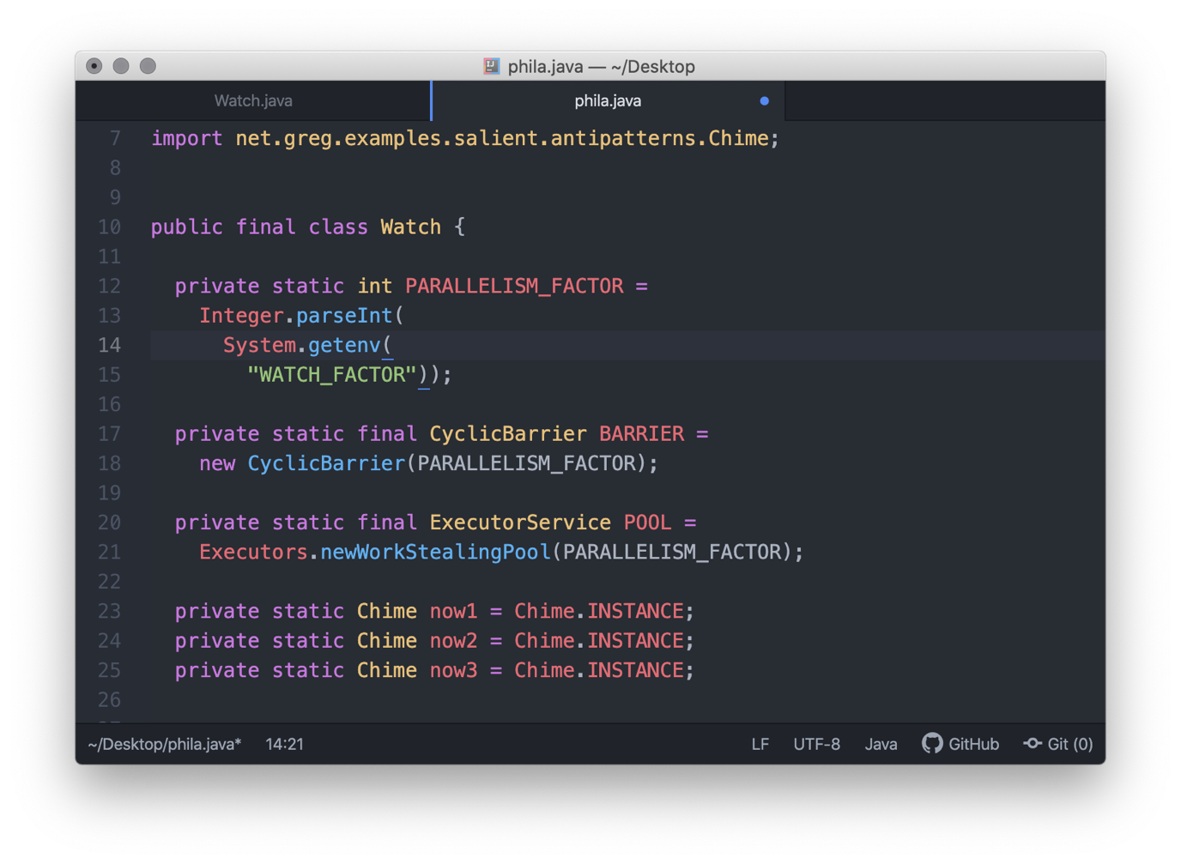

Lines 12-15

Creates the representation of the parallelism factor (the capacity/release-point of the CyclicBarrier).

The value of this factor is derived from an environment variable, which is named WATCH_FACTOR

(as espoused by the 12-Factor App credo).

Lines 17-18

Instantiates the CyclicBarrier.

Lines 20-21

Instantiates the Executor – a WorkStealingPool that takes advantage of all available CPUs.

Lines 23-25

Creates three Singletons.

There are (incongruously) 3 “Singletons” to disprove their uniqueness during testing, and to prove that, while not unique, it is fast enough to prove that even with enough Threads assailing it, it never experiences a race condition.

If a collision does ever occur – say, if we run the same volume of requests against just one such “Singletons” – then a Critical Section can be installed, or a lock at method scope can be installed (less preferable).

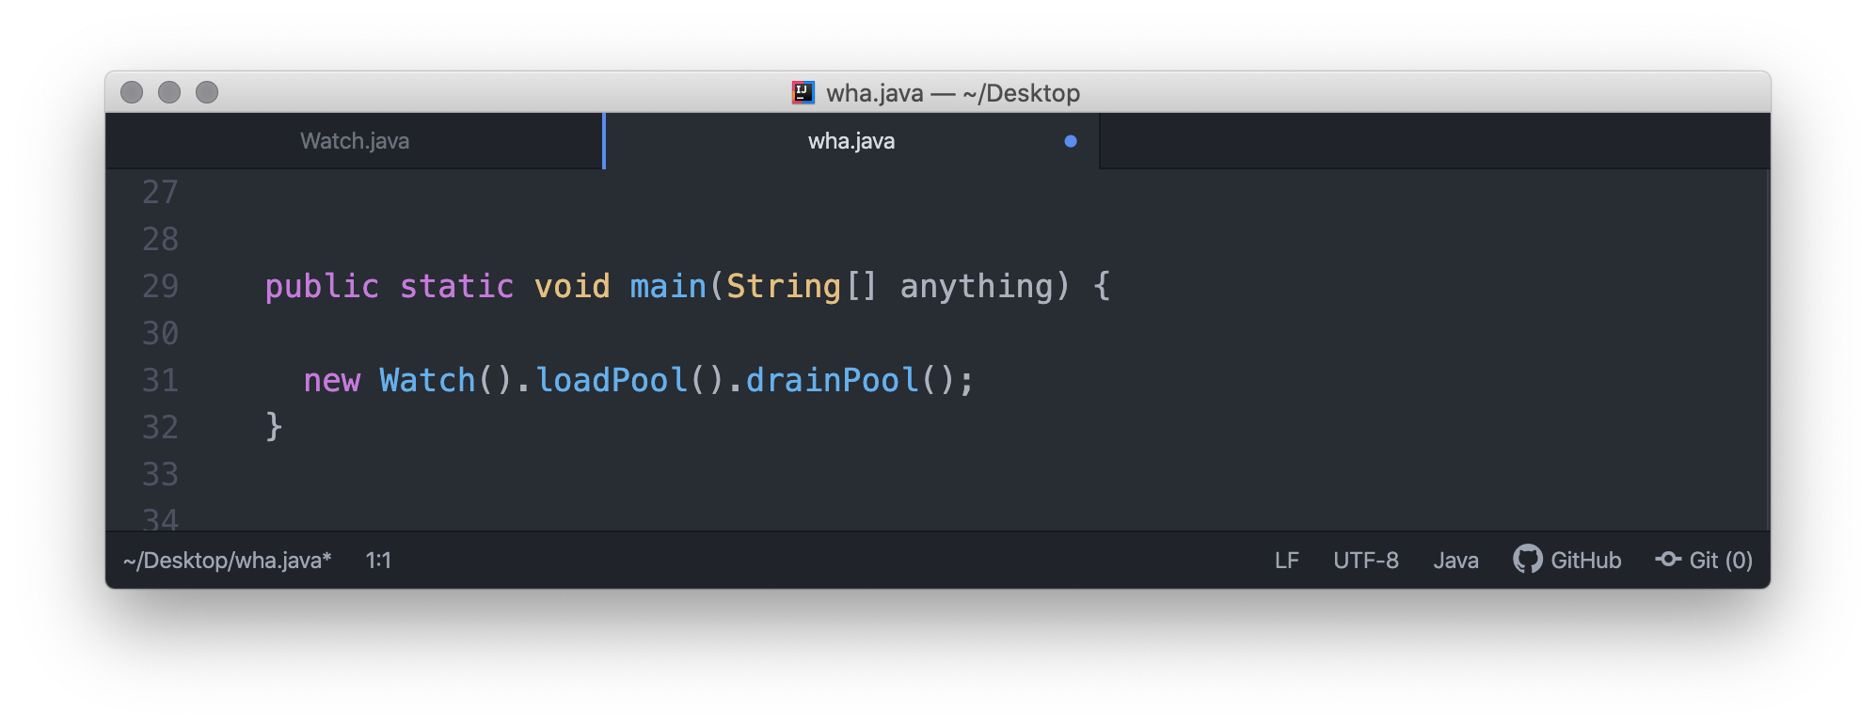

Above, the Builder Pattern is employed to chain methods together. First, a method is called to fill the ThreadPool, then another method is called to drain the ThreadPool.

It appears that no processing occurs, however, a narrative of the (sometimes unordered) sequence of events that happen as a consequence of utilizing a CyclicBarrier appears on the next page.



Sequence of Events, high-level narrative

As coded, this is the chain of events (asynchronicity distorts):

Watch.main --> Watch.loadPool() --> Watch.drainPool()

The actual sequence resembles this:

**Chime()** – constructor is called once (Singleton)...

This happens is in response to static instantiations in the Watch class

**Watch.main()**

**Watch.loadPool()** – Event: Loads/launches async threads which are named:

| Watch.ChimeAssailants (a nested class)

|

| **Watch.ChimeAssailant** – Event: Awakens, waits at the gate that it encounters

| within its run method.

| Event: Gate opens, the Watch.ChimeAssailant.run() method

| calls the Watch.inquire() method

**Watch.loadPool()** exits

Meanwhile, due to the latency of gate arrivals,

**Watch.drainPool()** method has already begun ...

|

| **Watch.ChimeAssailant().run()** starts, readout:

|

| Watch.ChimeAssailant.runID 0 waiting at Barrier

| Watch.ChimeAssailant.runID 0 executes the Watch.inquire() method

| **Watch.inquire()** responds with a readout:

| now1.createdTime() 2020-06-07T02:16:16.421846 **<---**

| now1.currentTime() 2020-06-07T02:16:16.485408

| now2.createdTime() 2020-06-07T02:16:16.421846 **<---**

| now2.currentTime() 2020-06-07T02:16:16.486361

| now3.createdTime() 2020-06-07T02:16:16.421846 **<---**

| now3.currentTime() 2020-06-07T02:16:16.486710

|

**Watch.drainPool()** finishes with a notification:

“POOL Shutdown Completes”



Singletons, creation of

To keep this demo focused, the Singletons are created sequentially.

Since there are no issues with the thread-safe instantiation of the Singletons, we instead focus on thread-safety with respect to how the Singletons instances respond under heavy load.

I have used 3 Singletons to provide variety in the readout.

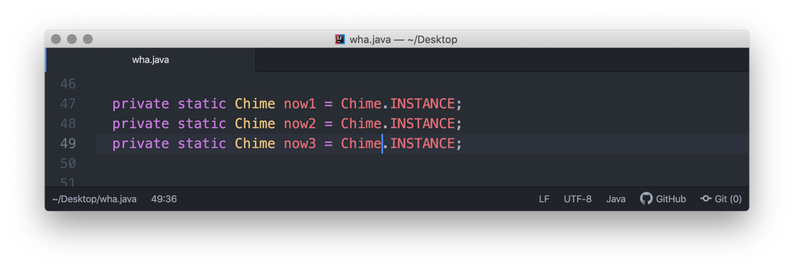

We (sequentially) ask for each of the Singleton instances via a simple, static factory reference.



Executor, by example

The instantiation of the newWorkStealingPool Executor class uses the constructor which accepts the default behavior of utilizing all free cores/CPUs.

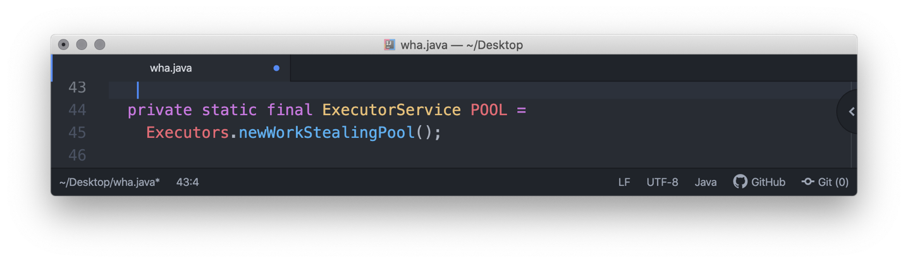

The population of the Executor.newWorkStealingPool class with (labeled) instances of the ChimeAssailant class. The pool fills, then its threads transition from a NEW state to a RUNNABLE state, and they immediately.

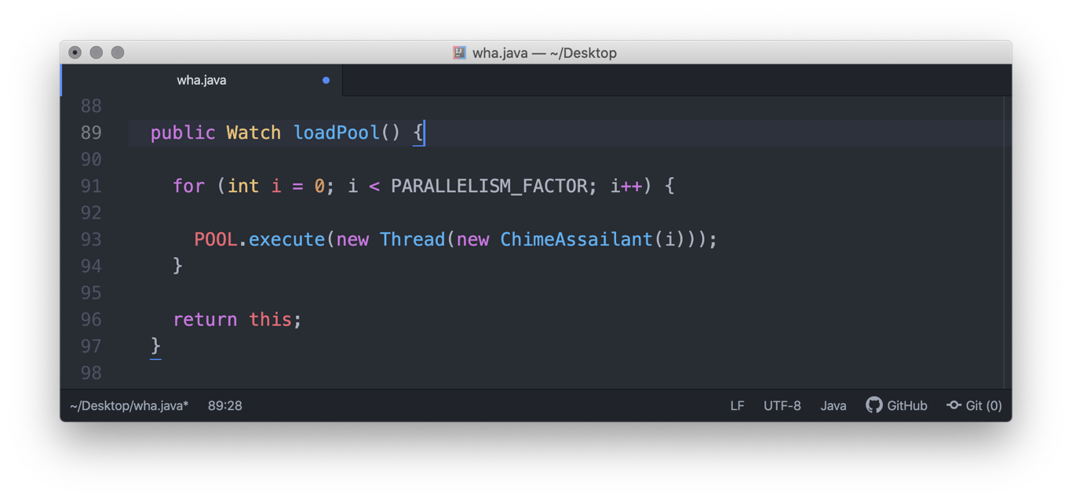

The graceful end to the Executor.newWorkStealingPool class’ lifecycle is wrapped in a member method of the Watch class, named drainpool().

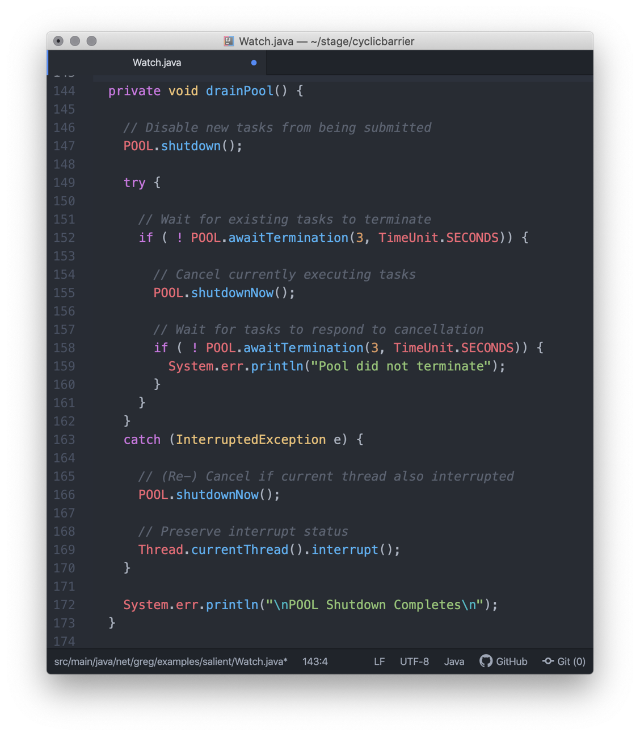

Line 147 Prevent new requests.

Line 152 Wait for tasks to finish up.

Line 155 Cancel any stragglers.

Line 158 Wait for stragglers’ response to cancellation.

Line 166 Cancel once again.

Line 169 Preserve any interrupt-status (of the current-thread-of-execution)



CyclicBarrier, by example

A CyclicBarrier is interposed in the canonical run() method of each of the running instances of ChimeAssailant.

The is ChimeAssailant intent on calling each of the 3 Singleton instance just once, then exiting. Calling the 3 Singleton instances within a loop is sequential, and we want to test the Singleton’s response to async requests.

The loop may create more demand than an equal number of ChimeAssailant (Threads).

The loop many be optimized by the HotSpot Compiler and become very efficient or ... not.

Measure. Decide.

In any case, we have many, many ChimeAssailant instances, which are all competing for time slices. We really want to test the interaction between many threaded single requests (ChimeAssailant/ Thread instances) and each Singleton.

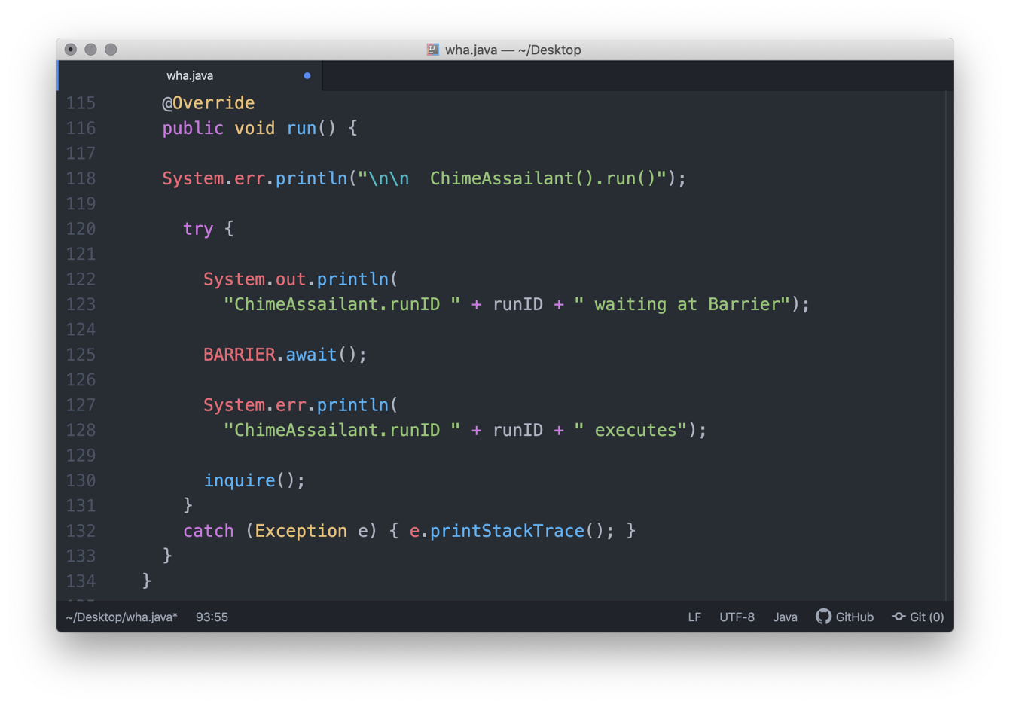

Line 116 – The canonical run() method of each instance of the ChimeAssailant Runnable/Thread class runs

its logic once.

Line 125 – The memory barrier (CyclicBarrier) is encountered.

The state of the ChimeAssailant (Thread) transitions to a WAIT state.

Line 130 – The canonical run() method of the nested ChimeAssailant class directly calls the static inquire()

method of its enclosing class, Watch.

Nested classes have free access to feature of its enclosing class).

Operation, scripts (an example)

This application’s binary image (JAR) is made executable by Maven’s Shade Plugin.

It’s the simplest POM possible.

There are a number of housekeeping/build/execute ßash scripts that produce the running application.

One example is the ok script, which allows the entire build/run (composite) CLI commands to be called in as simple a form as possible.

The CLI invocation of the ok script takes any one of these variants:

ok

. ok

source ok

The first command shown above only works if you install a similarly-named delegating ßash function inside the canonical ~/.bashrc file:

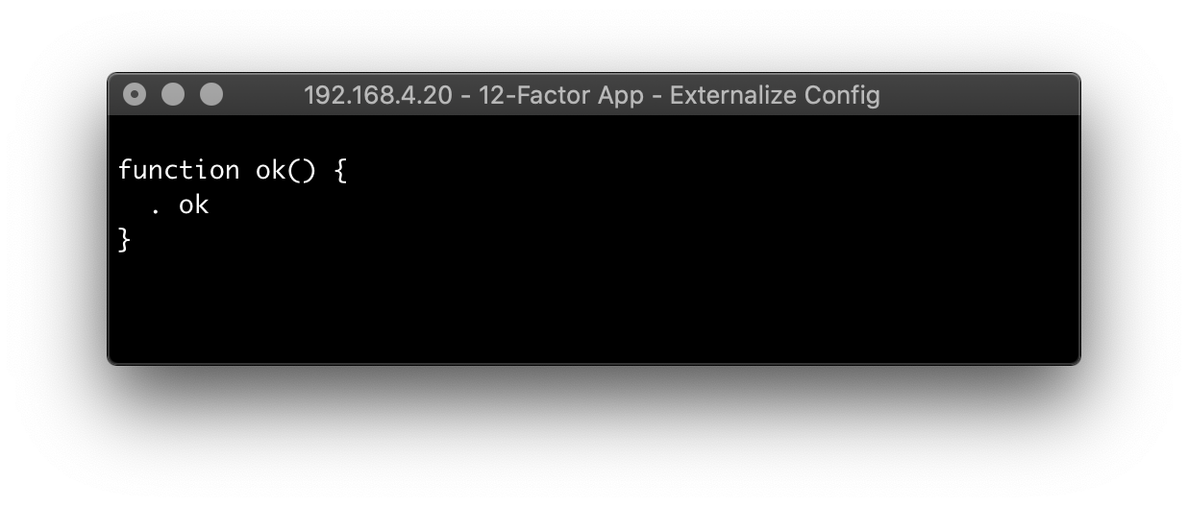

The above function allows for a globalized “pass-thru” functionality to be coupled/telegraphed to the same-named script, no matter it is.

So, for example, if you are in a directory that has a ßash script named ok, you just type ok to invoke the ok script.

This works because the (globally accessible) ~/.bashrc function already supplies the period operator (which is the equivalent of the keyword source).

continues

As for the local ßash script, there’s no need to mess with the naming/mistyping of the .sh file extension. Every time you invoke the script.

Just include the command-interpreter directive that is specific to your shell’s dialect (ßash), as shown on line 1, below:

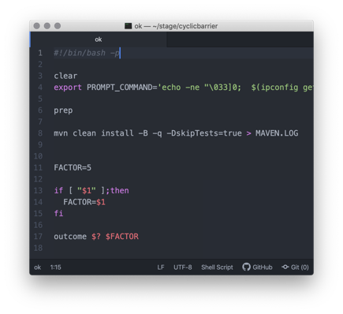

The command-interpreter directive assures that the value of the OS’s magic number (which the OS file type meta-descriptor) is unambiguous when referenced by the OS’s file system.



Build Cycle, CLI scripts

The set of ßash scripts for this application each perform an essential build/release step. They are meant to be chained together, much like ßash “utilities” are in Linux.

Most ßash/Linux “utilities” (are) more appropriately termed filters.

Each filter’s logic converts binary state, or data, or both, on behalf of the next filter in the processing chain.

All filters have a cohesive functionality, yet they can be combined with other (cohesive) filters in other chains (or. in a different order) to achieve a different objective/outcome.

The most effective order of chained scripts to achieve this app’s goal of a release (cleanup/build/deploy/run) flow is:

ok -- > prep -- > outcome -- > run

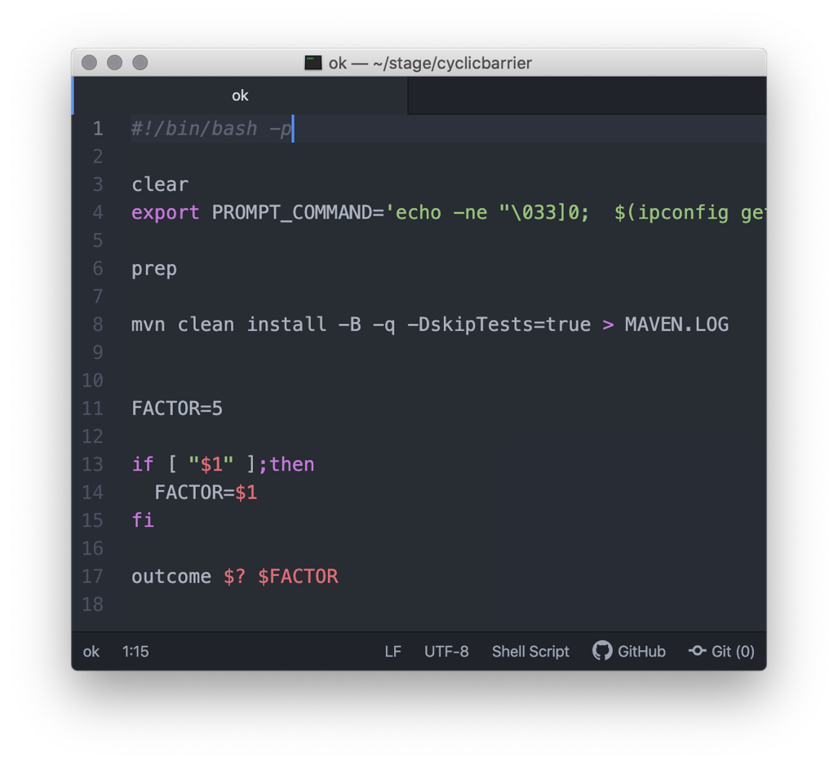

The ok script:

Accepts one optional argument that is a user-supplied value for the capacity for the CyclicBarrier.

Calls the prep script.

Performs maven clean install.

Redirects Maven’s (stdout) readout to a flat file.

Passes a pair of arguments to the outcome script, the value of the status flag from the last maven clean install, followed by the user-supplied CyclicBarrier capacity value.



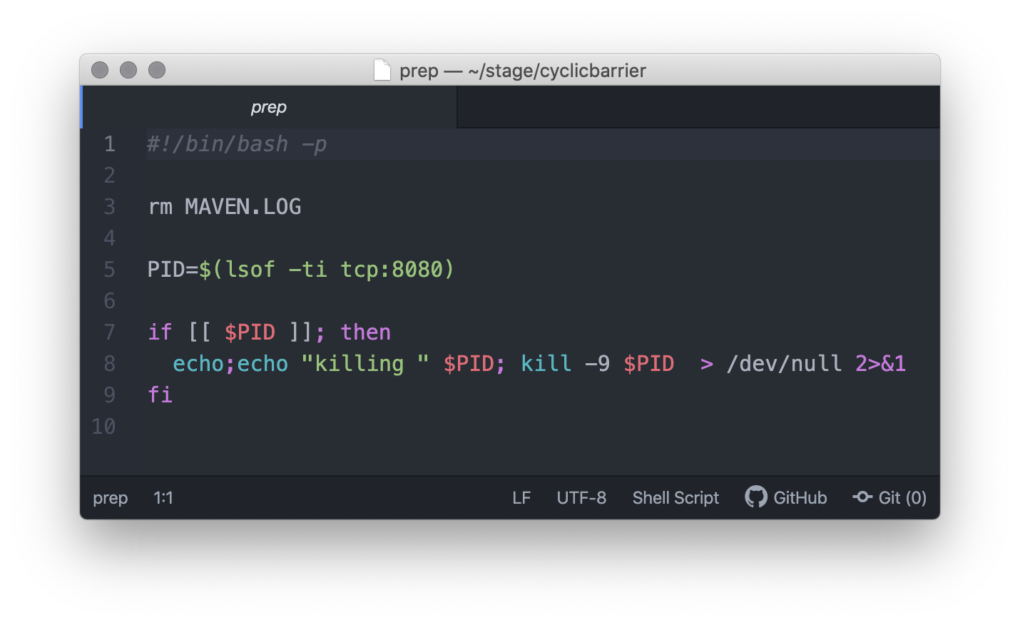

The prep script:

Clears the flat file log from the previous Maven build.

Leverages the OS’s lsof filter to identify the PID of any process that currently claims port 8080.

Forcibly kills that process.



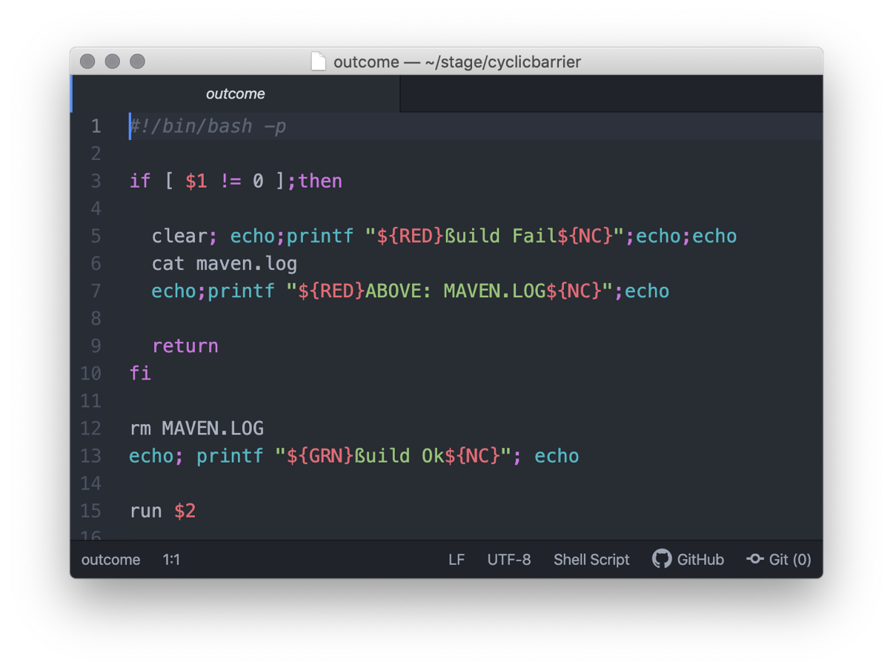

The outcome script:

Checks the value of the incoming Maven status flag for success (0).

If a fail status, sends the contents of the flat file that contains the Maven build log to stdout.

Deletes that file.

Calls the run script, passing the user-supplied capacity value to the run script.



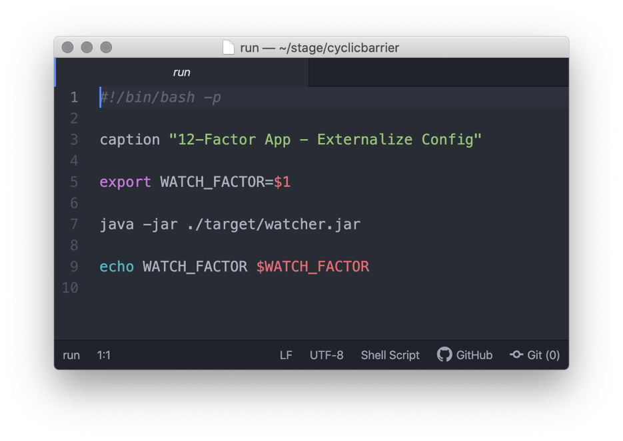

The run script

Assigns the incoming user-supplied capacity value to an environment variable, which is named WATCH_FACTOR for use by the application.

invokes the application.

Verifies the value of the environment variable.



Application, running state

A. Watch Factor of 1.

The ChimeAssailant barrages the Singleton.

Across each instance of Singleton, the value of the createdTime attribute remains identical.

Across each instance of Singleton, the value of the currentTime method is dynamic and varies.

Wall time: 42 ms.

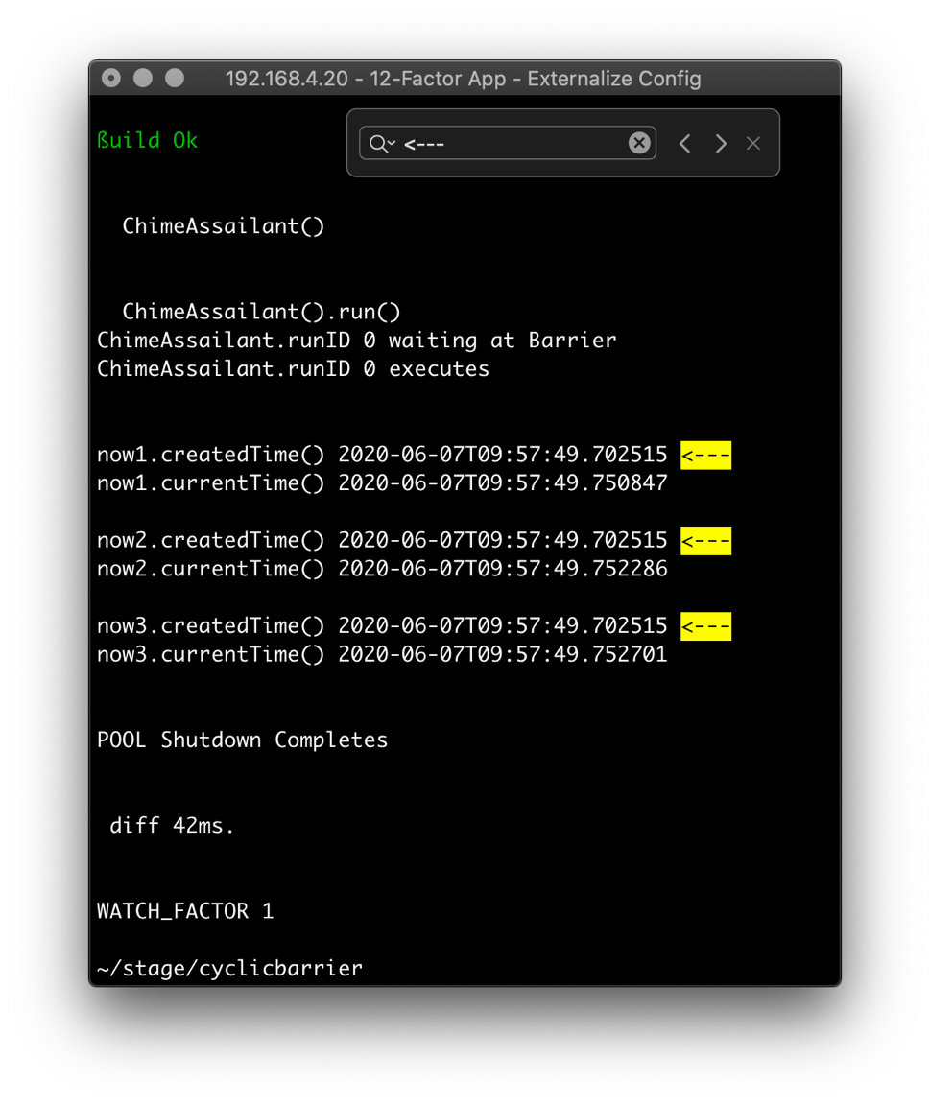



Factor of 5 (by default).

The ChimeAssailant barrages the Singleton.

Across each instance of Singleton, the value of the createdTime attribute remains identical.

Across each instance of Singleton, the value of the currentTime method is dynamic and varies.

Wall time: 56 ms.

4 screen shots.

|  |  |
| --- | --- |
|  |  |

|  |  |
| --- | --- |
|  |  |



Factor of 333.

The ChimeAssailant barrages the Singleton.

Across each instance of Singleton, the value of the createdTime attribute remains identical.

Across each instance of Singleton, the value of the currentTime method is dynamic and varies.

Wall time: 288 ms.

NB Here, the scaling afforded by the Executor.newWorkStealingPool class begins to become apparent

when the Wall times of the 3 applications’ elapsed times are compared, looking at throughput:

|  |  |  |
| --- | --- | --- |
| Threads | Wall time (ms.) | Throughput |
| 1 | 42 | 0.024 |
| 5 | 56 | 0.09 |
| 333 | 288 | 1.16 |



**Threads Wall time**

1 42 ms.

5 56 ms.

333 288 ms.



Five samples follow, one per page.

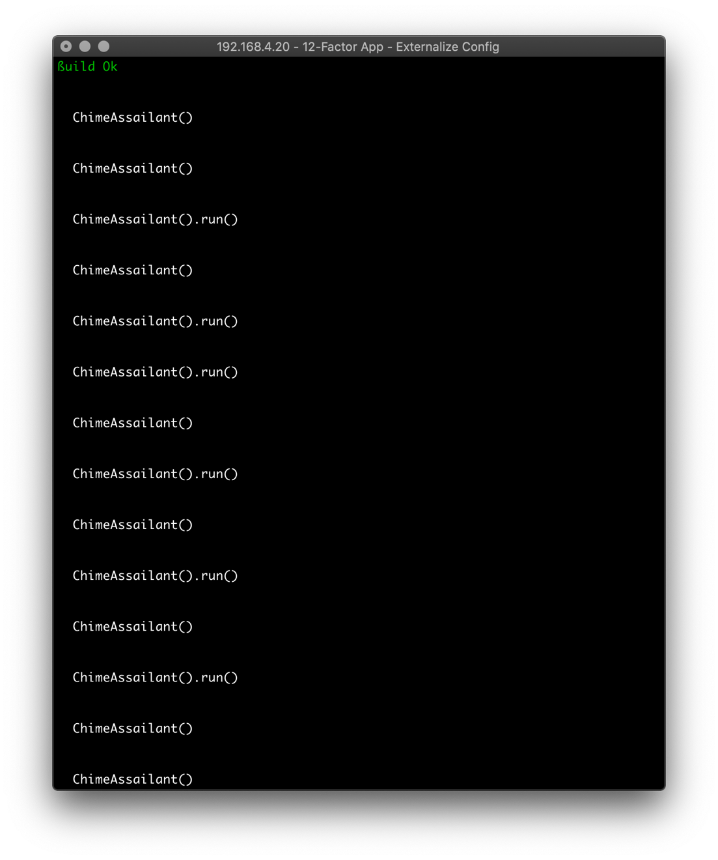

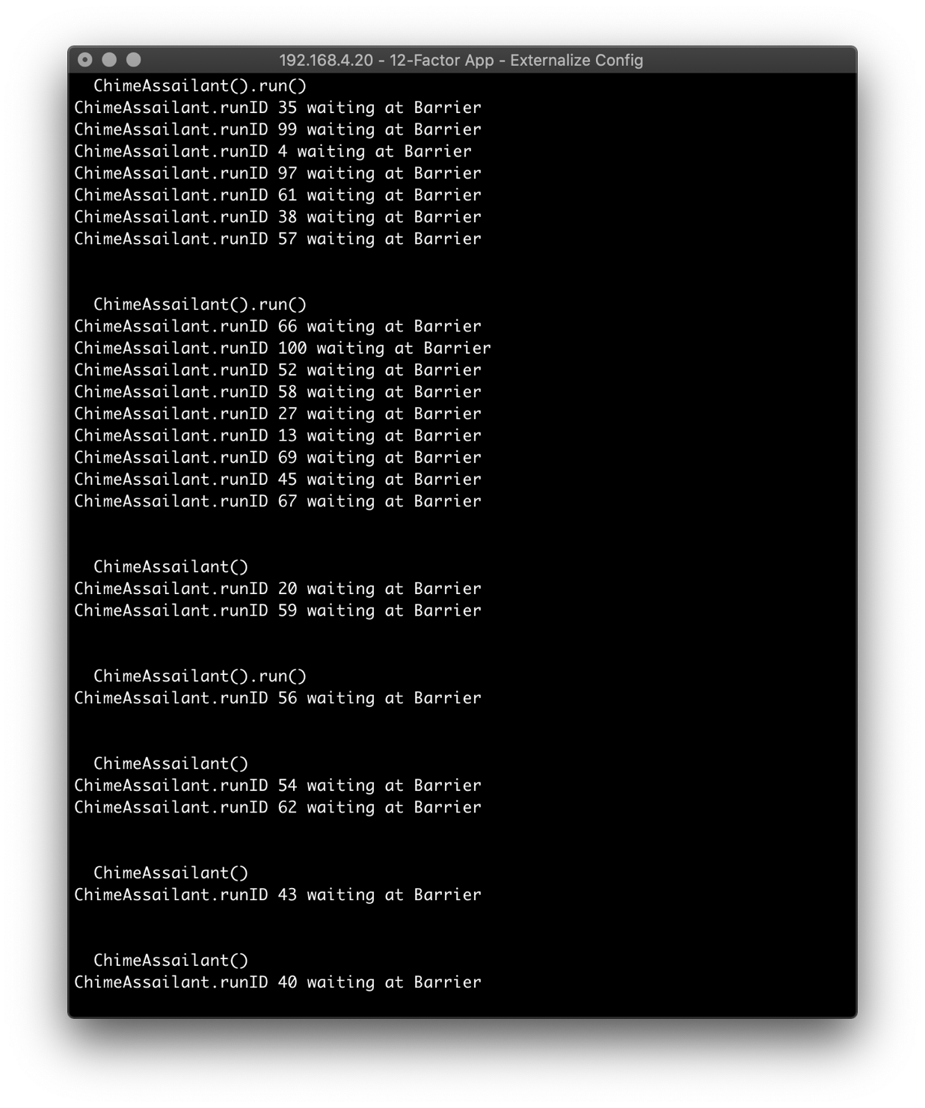

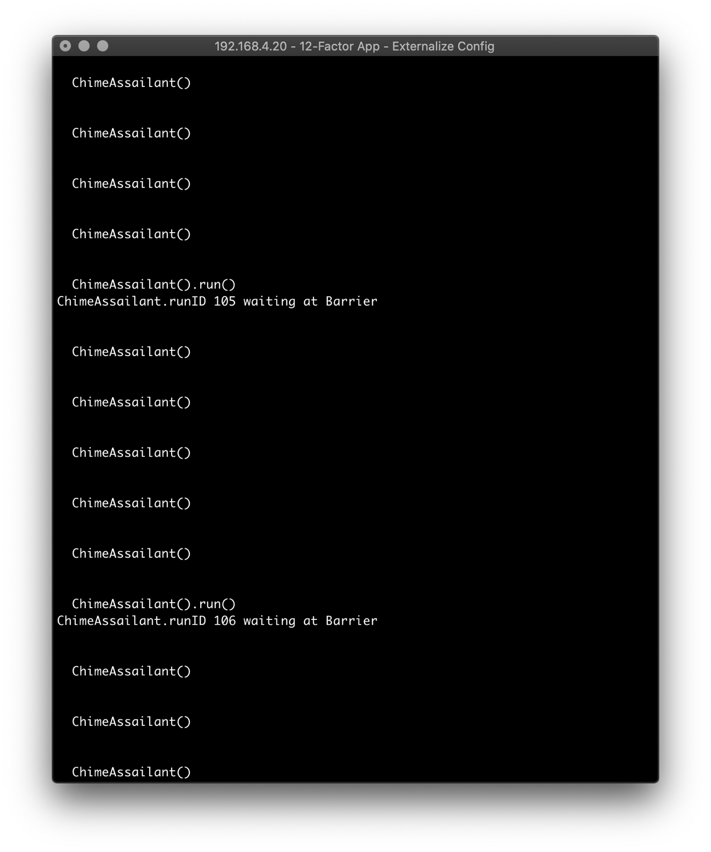

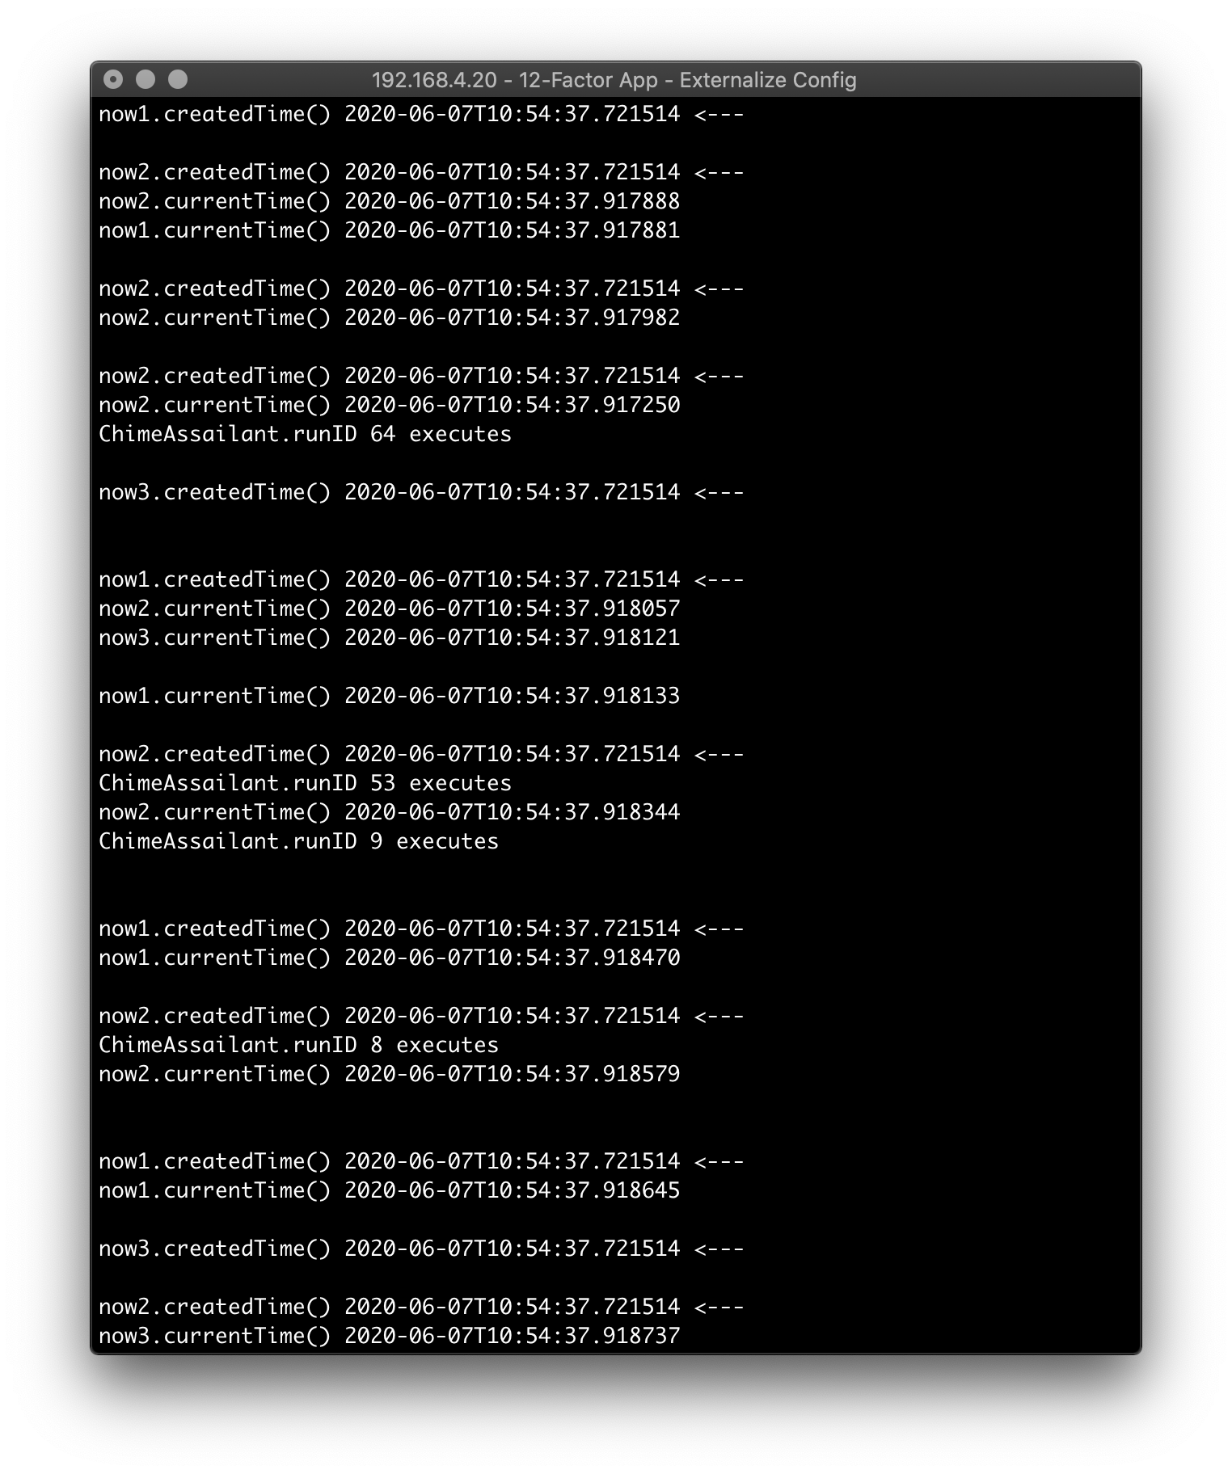

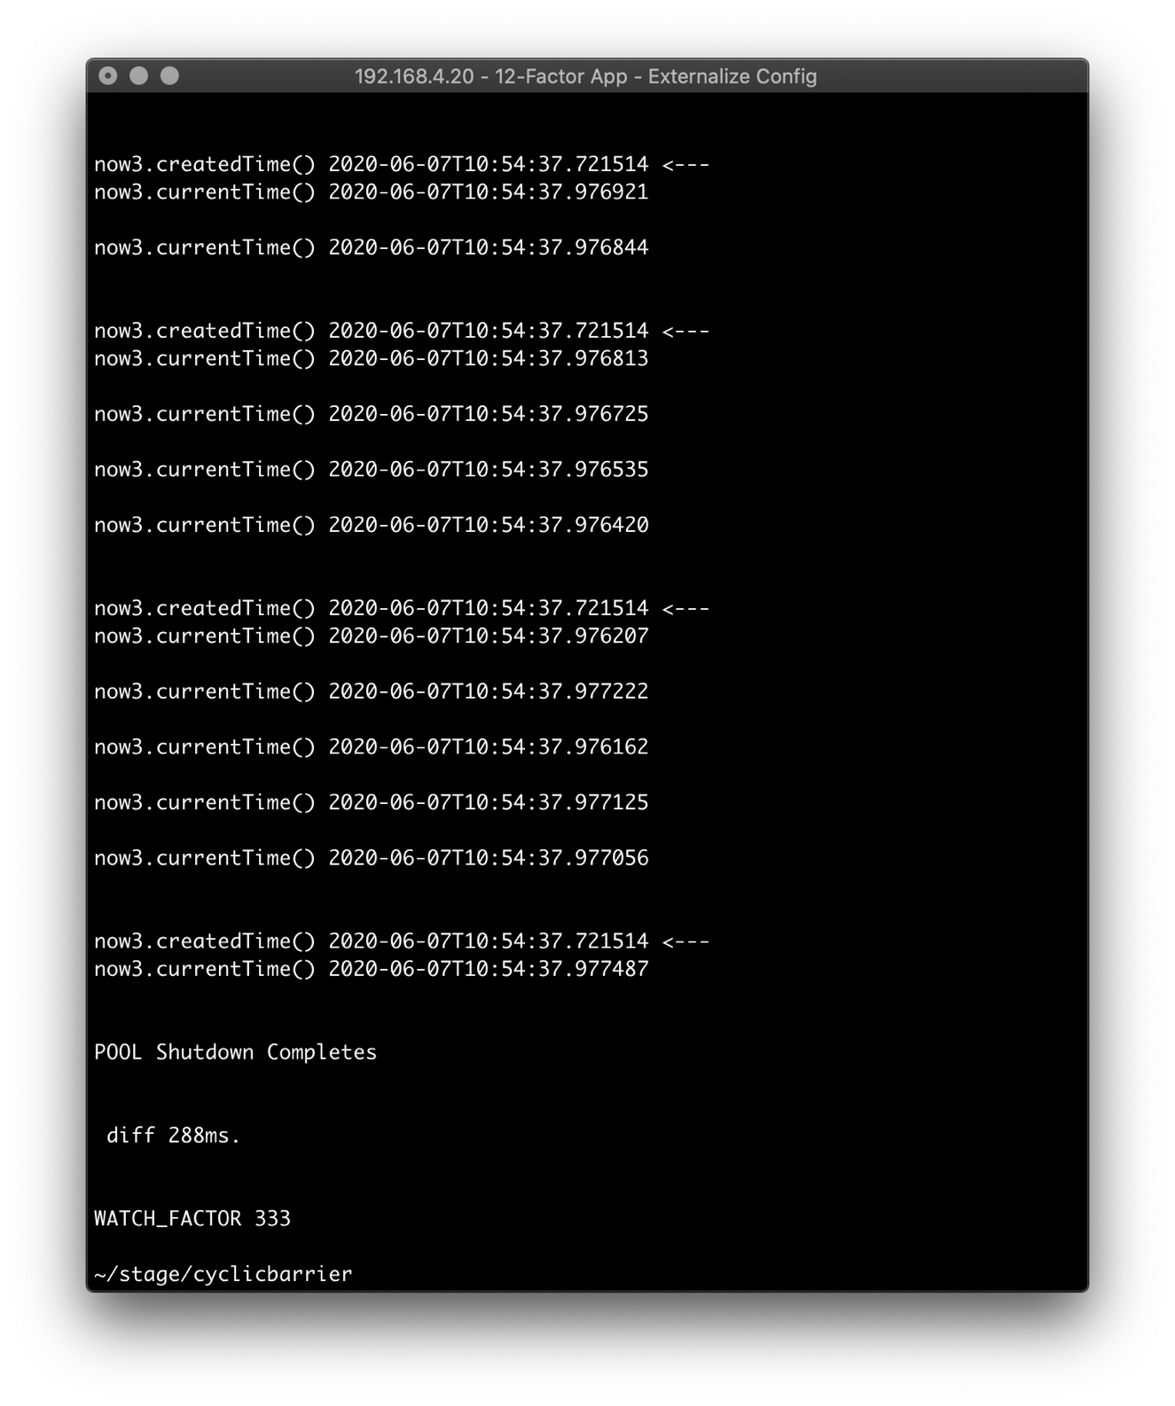

Factor of 3333.

The ChimeAssailant barrages the Singleton.

Across each instance of Singleton, the value of the createdTime attribute remains identical.

Across each instance of Singleton, the value of the currentTime method is dynamic and varies.

Wall time: 4867 ms.

NB Here, the scaling afforded by the Executor.newWorkStealingPool class begins to break down.

I did a fifth run and found improvement when the thread count was 1,000.

So, for the Wall times of 5 applications runs elapsed times are compared, looking at throughput:

|  |  |  |
| --- | --- | --- |
| Threads | Wall time (ms.) | Throughput |
| 1 | 42 | 0.024 |
| 5 | 56 | 0.09 |
| 333 | 288 | 1.16 |
| 1000 | 853 | 1.17 |
| 1500 | 1314 | 1.14 |
| 2000 | 2319 | 0.86 |
| 3333 | 4867 | 0.68 |



Threads Wall time

1 42 ms.

5 56 ms.

333 288 ms.

1000 853 ms.

1500 1314 ms.

2000 2319 ms.

3333 4867 ms.



The degradation might be due to a hardware constraint.

Increasing the heap allocation does not help.

java -jar -Xms1g -Xmx1g ./target/watcher.jar

Shutdown Hook

A Shutdown Hook is an initialized but un-started Thread.

As an application is exiting – whether in a controlled/uncontrolled way – the JVM transitions the registered Shutdown Hook (a Thread) to the STARTED state, then to the RUNNABLE state.

Logic in the Shutdown Hook then executes.

The application is *provisioned* to use Java’s canonical Shutdown Hook; however, the Shutdown Hook is not necessary/used because the Executor.newWorkStealingPool class has robust EOL lifecycle logic.

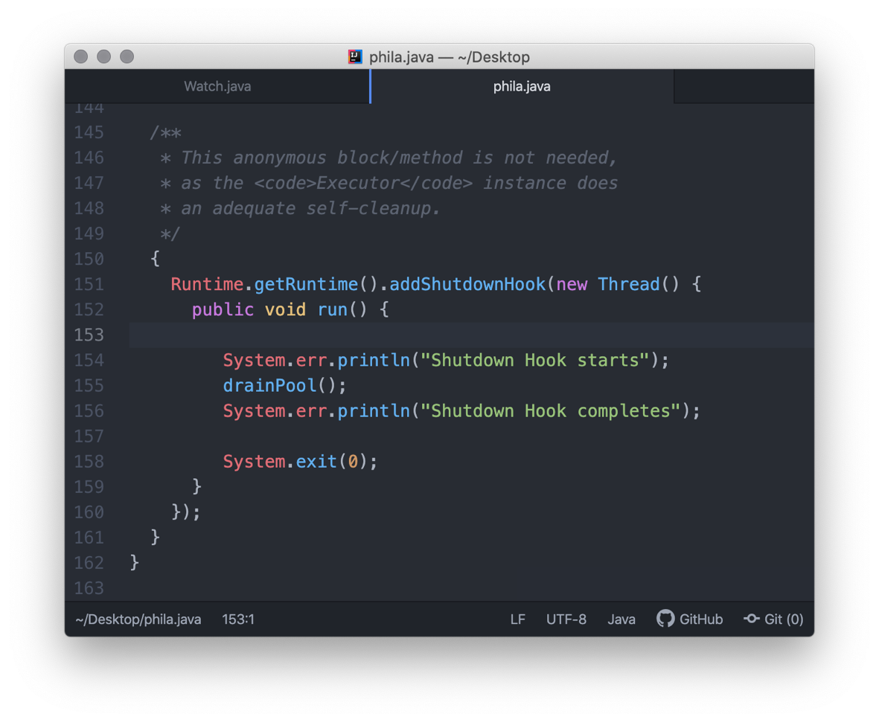



Exploits

A good Singleton protects against backdoor exploits that can compromise its state. Ideally it is *stateless*, or its state is immutable.

One such exploit involves Reflection.

The Chime Singleton class in an attempt prevent Reflection, shortsightedly disables Java’s Security Manager with the aim of disabling the default security policy that allows Reflection to occur (limited to the current JVM).

However, by the wholesale disabling of Java’s Security Manager, key capabilities, such as Modify Thread state, Shutdown Hook operation are also lost. Attempts to utilize these key capabilities will result raising a java.security.AccessControlException by the Java Runtime.

The code runs fine – until it tries to perform an action (granted by) the default Security Manager). Of course, the rescission of certain policies could be intentional. Still, if you can compile the code, you can also reinstate the policies, ad hoc.

This is a shortsighted remedy – the Chime Singleton class could just throw a RuntimeException instead.

I elected to do this to demonstrate how to recover from this situation. Any rogue code, introduced and not detected, can disable the Security Manager).

This topic should probably be (and likely is) part of a rudimentary white-hat pen-test.

One (not code related) remedy to reinstate any of the lost capabilities involves adding grant {} statements to the Java canonical security file: $HOME/.java.policy

This canonical file is nonetheless hidden by having been named with a leading period.

